Name______________
Welcome to Band !!!!!
What would you like me to know about you?

How can I best help you with your instrument?

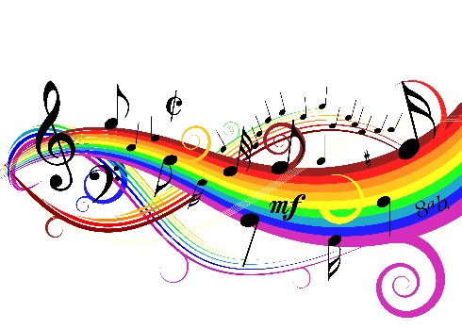
What is your favorite song?

Circle the fact about me that is NOT true.
- I was born in Japan
- I am a professional flutist
- I sometimes play the accordion in a German Band
- I sometimes play the organ in a church
- My daughter is adopted from China
Mrs. Rakas

